**Run Image Classification on colab instruction:**

1. Change Run time to “**GPU**”.

- go to “**runtime**”

- click on change “**runtime type**”

- Change from “**CPU**” to “**GPU**”

1. Upload the zip file provided with the name “**UI_based_image_classification.zip**“ on colab.
2. Run the 1st cell with commands:

!pip install flask-ngrok

!pip install fastbook

1. Run the 2nd cell with commands:

!unzip UI_based_image_classification.zip

%cd UI_based_image_classification

It will run unzip the file “**UI_based_image_classification.zip**” and then move in the directory.

1. Run the 3rd cell with command:

!python app.py

1. Now you’ll get

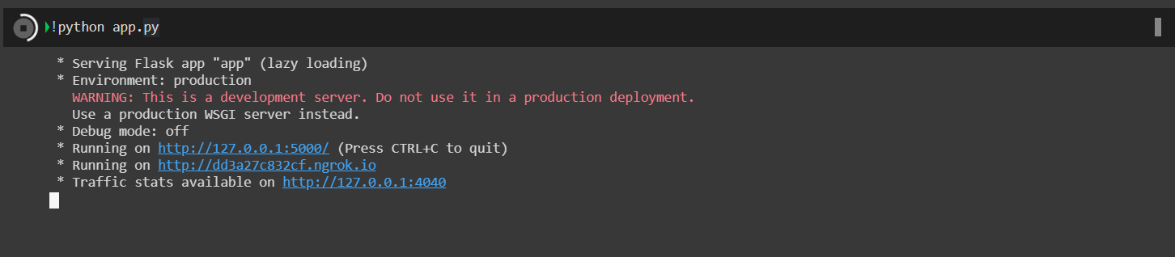

In the above given image click on the link having “**ngrok.io**” i.e the 2nd one.

1. In the Home page will open:

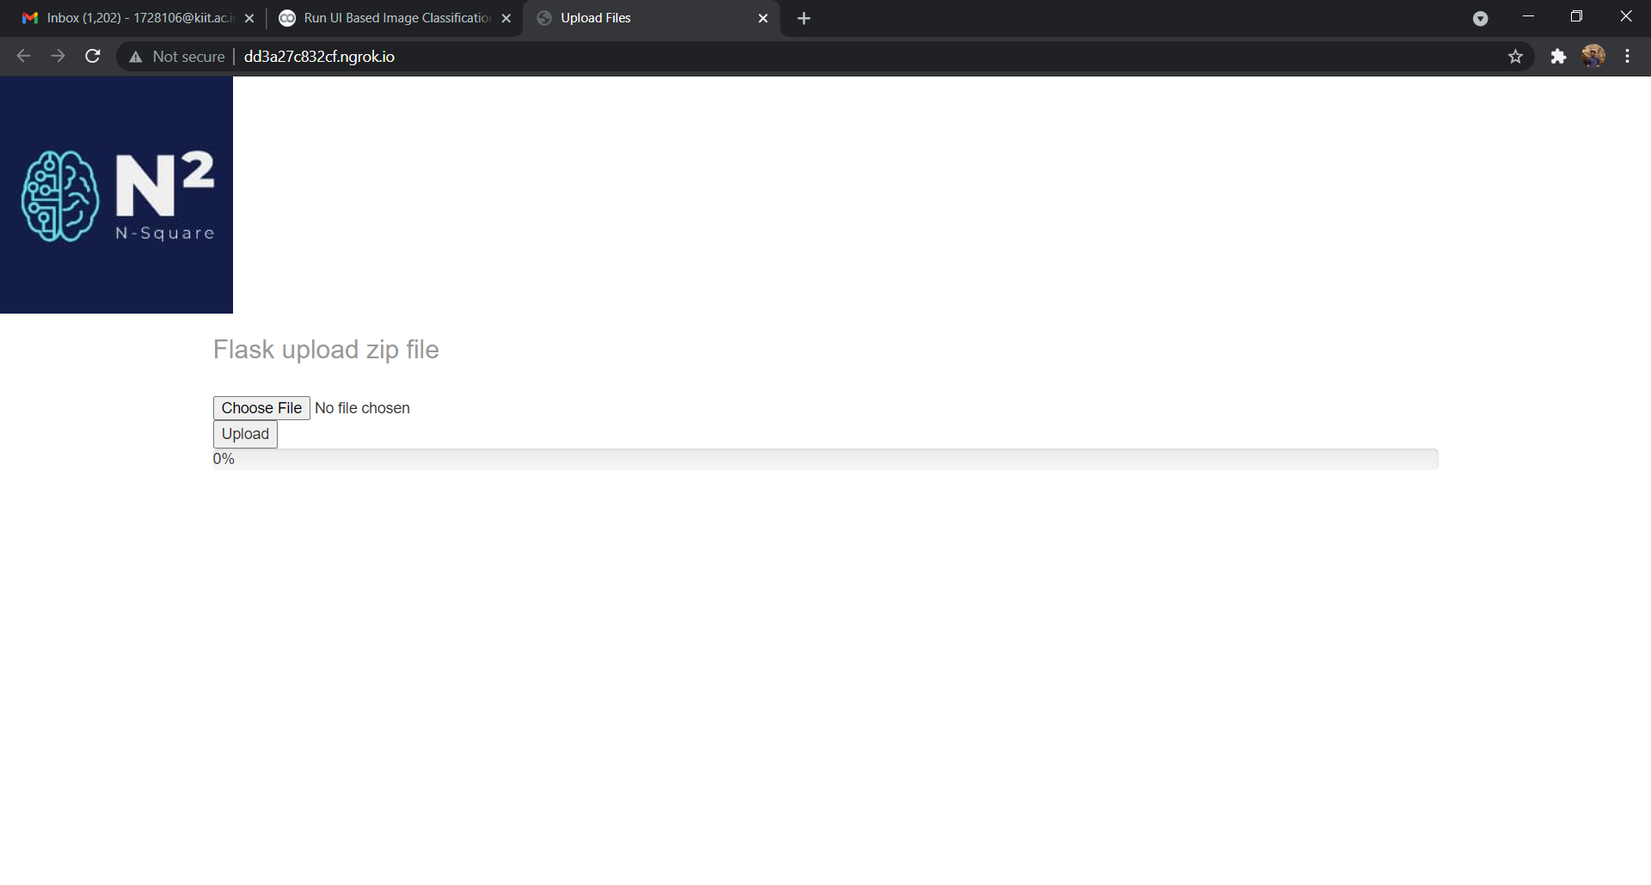

- click on **Choose File** and then select “**train.zip**” file then click on **Upload**.

1. You’ll have the 2nd screen with following options:

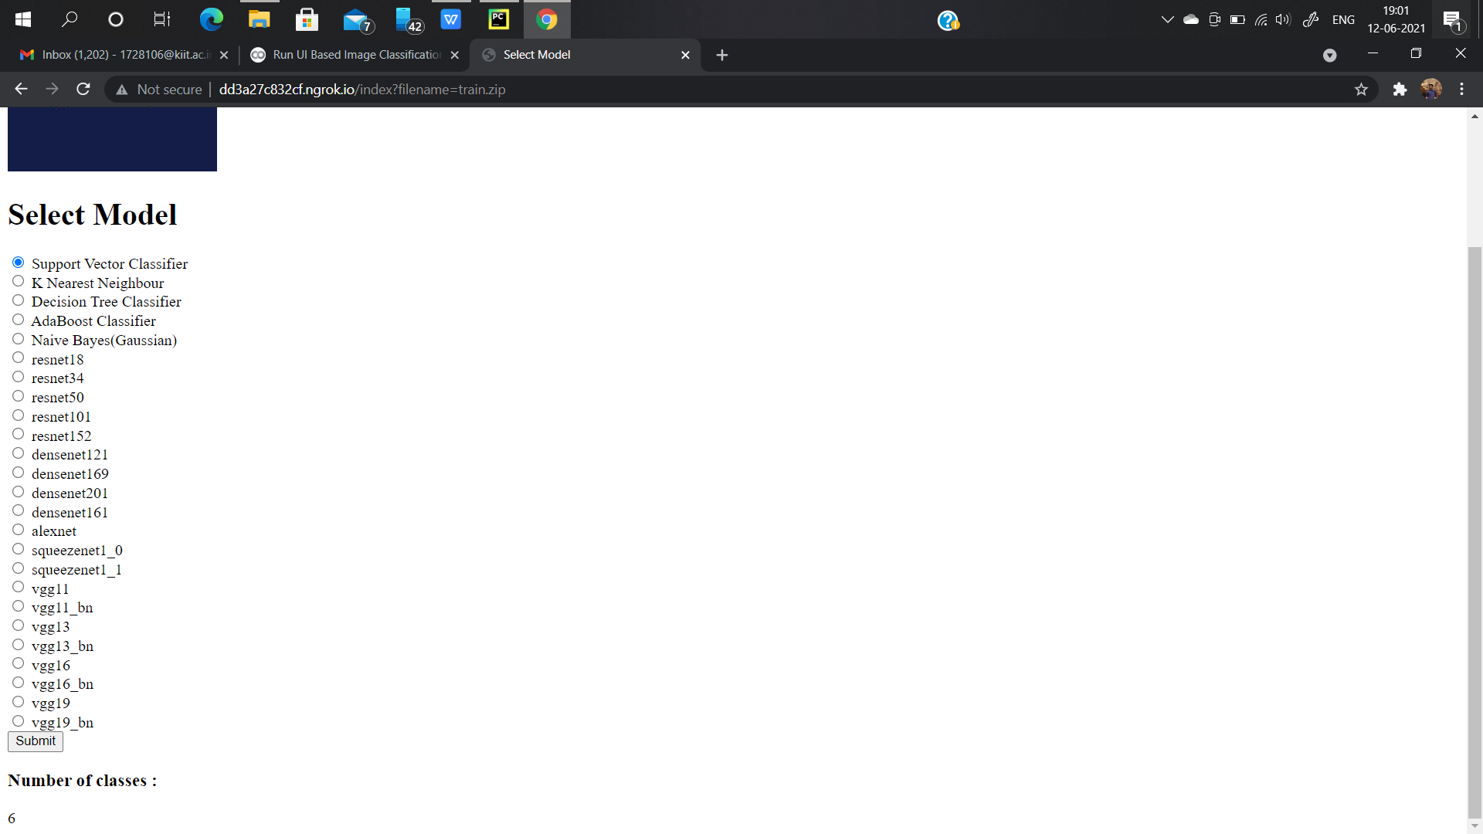

- Select the model and then click on submit.

1. The 3rd Screen Model Tuning and training:

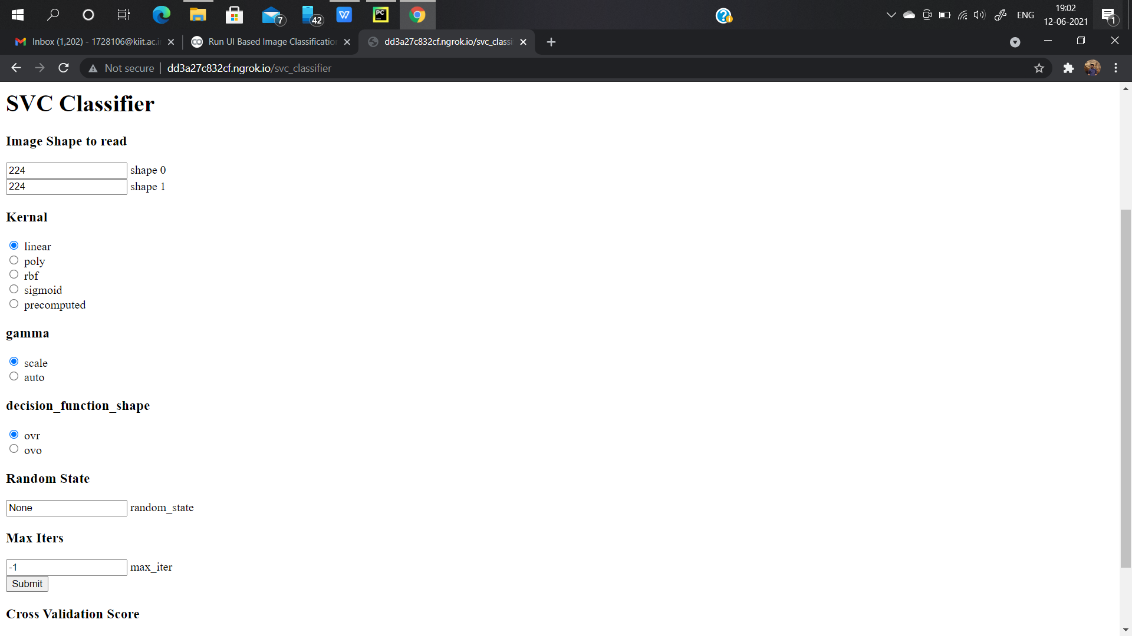

- Select your options and click submit.

1. For Deep Learning you need to do the same:

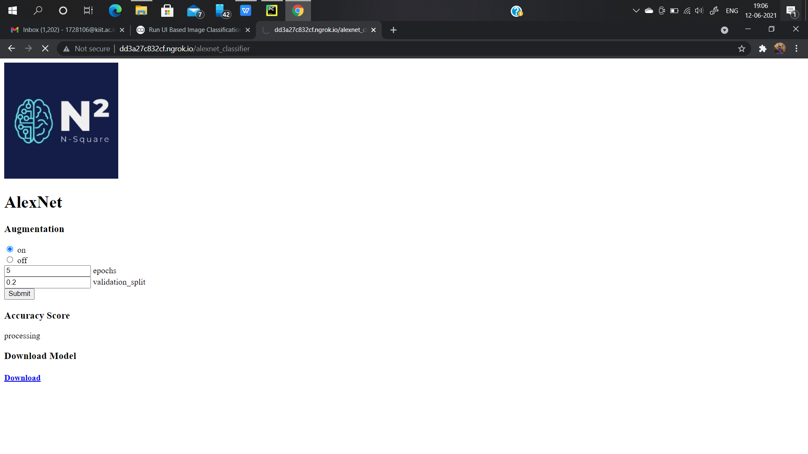

- After Calculation and computation you’ll get the scores in the below given Area **“Accuracy Score”**.